**12 Physics**

**Semester 1 Exam**

**Section A Questions**

**Question 1 (4 marks)**

The diagram below shows two planets ‘X’ and ‘Y’ which have masses of ‘m’ and ‘5.00m’ respectively.

[The measurements described in this question for Planet ‘X’ and Planet ‘Y’ are made independently of each other.]

d

d

Planet ‘X’ with a mass of ‘m’

Planet ‘Y’ with a mass of ‘5.00m’

The gravitational field strength is measured at a distance ‘d’ from each planet’s centre of mass (as shown). The gravitational field strength due to Planet X at distance ‘d’ is measured to be 2.50 ms-2. Calculate the gravitational field strength at distance ‘d’ from Planet Y.

**Question 2 (4 marks)**

A bird is able turn in a circular path of radius ‘r’ at a particular speed ‘v’ by banking its wings at an angle (θ) to the horizontal towards the centre of this path. See below.

Plane of the bird’s wings

θ

Explain why the angle of banking ‘θ’ of the bird needs to increase if the radius of its circular path decreases while maintaining the same air speed (v). Include an appropriate mathematical expression and a vector diagram to aid your answer. You can assume that any lift forces are perpendicular to the plane of the bird’s wings.

**Question 3 (4 marks)**

Estimate the minimum horizontal force required to tip over a fully-filled 1 litre Coke bottle with a base width of about 7 cm and a height of about 30 cm. Clearly state any assumptions you make while answering this question. Draw any appropriate forces and distances on the diagram.

**Question 4 (4 marks)**

An eagle of mass 55.0 kg swoops down on its prey. It follows a circular arc of radius

87.0 m and is travelling at a top speed of 27.0 ms-1.

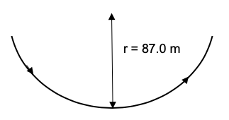

(a) Ignoring air resistance, calculate the maximum force experienced by the eagle’s wings as it catches its prey. (3 marks)

(b) Clearly state the point at which this maximum force occurs. (1 mark)

**Question 5 (5 marks)**

A projectile is fired upwards at an angle to the horizontal and lands at the same height from which it is launched.

(a) Which pair of graphs best describes:

(i) the vertical component of the projectile’s velocity (v); and

(ii) the projectile’s acceleration (a) as a function of its flight time (t). (2 marks)

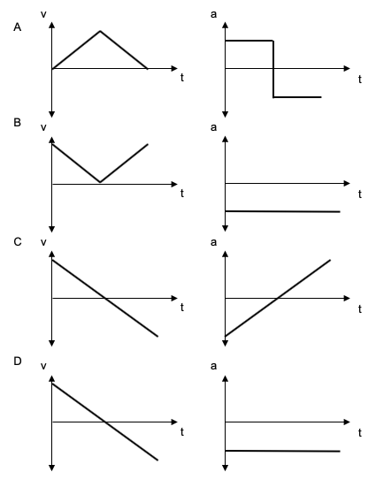

Answer:

(b) On the axes below, sketch a graph for the vertical component of the projectile’s velocity (v) as a function of its flight time (t) ***when air resistance is taken into account*.** No values need to be written – but relative sizes of quantities must be shown. (3 marks)

v

t

**Question 6 (7 marks)**

A pair of parallel metal plates, placed in a vacuum, are separated by a distance 4.00 mm and have a potential difference of 1.20 kV applied between them.

(a) Calculate the magnitude of the electric field between the two plates. (2 marks)

(b) Calculate the magnitude of the electrostatic force acting on an electron placed between the plates. (2 marks)

A beam of electrons is fired between the plates at a speed of 4.50 x 106 ms-1 in the direction shown.

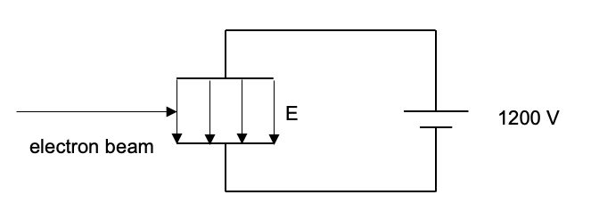

A magnetic field is applied to the electron beam sufficient to allow the electron beam to pass between the plates without deviating.

(c) On the diagram, indicate the direction of this magnetic field. (1 mark)

(d) Hence, calculate the magnitude of the magnetic field required. (2 marks)

**Question 7 (6 marks)**

An unusual electrical generator consists of a 1.10 m long conducting rod moved with a constant velocity through a magnetic field of strength 1.30 T. The force required to move the conductor in this way is equal to 8.90 N. The ends of the conducting rod are connected to a 1.20 Ω resistor. This arrangement is shown below.

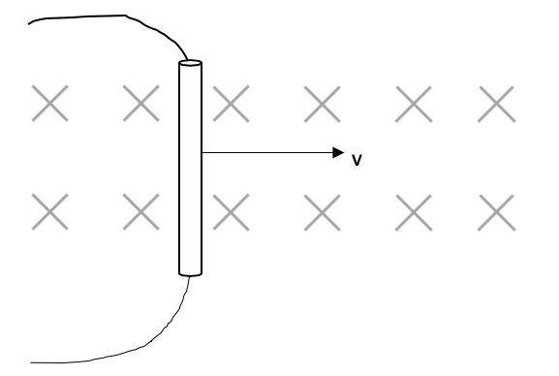

(a) On the diagram, indicate the direction of conventional current in the conducting rod.

(1 mark)

(b) Calculate the constant velocity ‘v’ of the conducting rod. (5 marks)

**Question 8 (3 marks)**

Two positively charged point charges of magnitude (in Coulombs), ‘q1’ and ‘q2’, are separated by a distance ‘d’ and experience an electrostatic force ‘F’. The charge sizes are changed to ‘2q1’ and ‘3q2’ and the distance is reduced to ‘0.50d’. Calculate an expression for the electrostatic force between these two charges in terms of ‘F’.

**Question 9 (6 marks)**

The diagram below shows the structure of a simple DC motor. A rectangular coil (ABCD) consisting a single loop is sitting in a magnetic field created by the poles of two bar magnets (X and Y).

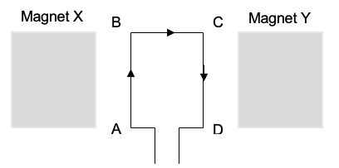

(a) As shown by the arrows on the coil, at a particular instant in time, conventional current flows from A to D. At this instant, side AB experiences a force OUT OF THE PAGE and side CD experiences a force INTO THE PAGE. In the spaces provided below, write down the polarity (North or South) of Magnets X and Y that would create these forces. (1 mark)

MAGNET X: _________ MAGNET Y: _________

The dimensions of the coil are as follows: AB = CD = 20.0 cm; BC = AD = 10.0 cm. The current flowing is equal to 1.50 A and the strength of the magnetic field is 0.400 T.

(b) Calculate the torque acting on the coil when it is in this position. (3 marks)

(c) On the set of axes below, SKETCH how the torque experienced by this simple DC motor would vary over the course of ONE FULL ROTATION. Assume that a commutator is present in the motor and the coils starts in the position shown in the diagram above. (2 marks)

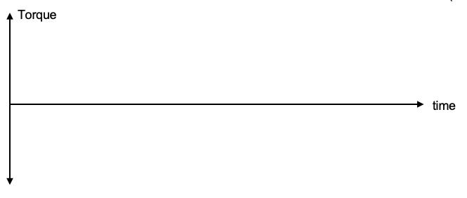

**Question 10**

A proton with a speed of 1.70 x 107 ms-1 enters a mass spectrometer that has a magnetic field of 3.00 T. It is bent into a circular arc by this magnetic field and crashes into the detector as shown below. In the questions that follow, ignore relativistic effects.

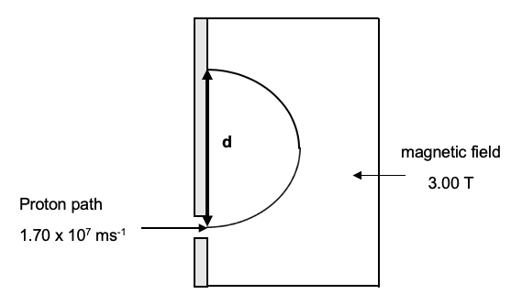

(a) On the diagram, in the region labelled ‘magnetic field’, draw the direction of the field that would bend the protons into the path shown. (1 mark)

(b) Calculate the distance ‘d’ shown on the diagram. Show working. (4 marks)

**Question 11 (4 marks)**

A 20.0 kg sign is hung off the end of a uniform beam of length 80.0 cm and mass 15.0 kg. The beam is fixed to the wall and forms an angle of 60.0° to the vertical as shown in the diagram below. It is held in place by a horizontal wire, which can safely withstand a maximum tension of 2.00 x 102 N.

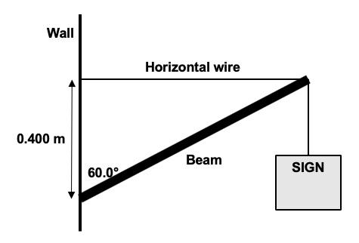

Will the wire snap? Answer by calculating the tension T in the horizontal wire when it holds the beam in the position shown. Show your working.

**Question 12 (8 marks)**

A student sets up the equipment below to study electromagnetic induction.

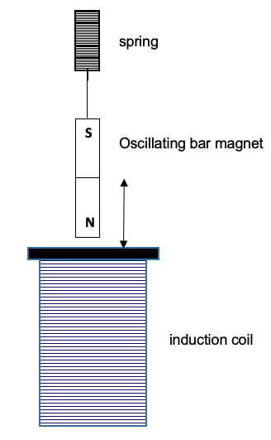

The bar magnet is initially pulled downwards, stretching the spring. It is then allowed to oscillate freely in an upwards and downwards direction as indicated by the arrow in the diagram. When the spring is fully stretched, the magnet is in the middle of the coil. After a short period of time, the student notices that the oscillation of the bar magnet ceases.

For the questions that follow, losses of energy in the spring and due to air resistance can be considered to be negligible.

(a) Consider the bar magnet as it moves in an UPWARDS direction out of the induction coil. On the coil in the diagram, draw an arrow to indicate the direction (i.e. to the left or right) of the conventional current induced. (1 mark)

(b) As time proceeds, the student notices that the amplitude of the magnet’s oscillation DECREASES to zero. Explain why using electromagnetism concepts. (3 marks)

(c) On the set of axes below, sketch how the induced EMF in the induction coil will change until it reaches a value of zero. Assume it starts in the position described in the introduction to this question. (4 marks)

